Kelby Kramer

Mr. Thompson

Metal Kinetics F

10/17/2014

Design Portfolio

Design Scenario:

I am going to be making a hydroelectric power generator. I chose my project because I have done a similar project in the past, my eighth grade science far project, and I would like to refine it both in construction and in efficiency. I intend to use my project to demonstrate the possibilities of hydroelectric power generation on a small scale. I also intend to use it to charge a battery pack that has a USB output so it can charge multiple devices.

Design Brief:

I am going to make a small scale Kaplan turbine hydroelectric power generator. It will be able to hold up to 1.5 gal of water, and be run through a 1 1/2 in pipe. It will create a small amount of storage able energy that can be collected in a battery pack. The complete frame (with water) of the generator itself will be 1 ft. squared and less than 3 ft. tall, weighing around 30 lb. The fact that I am working with water will increase the time necessary to for many of the construction processes due to the need for it to be watertight.

Research:

8th grade science fair project: Much of my knowledge was gained from past experiences where I designed a similar project.

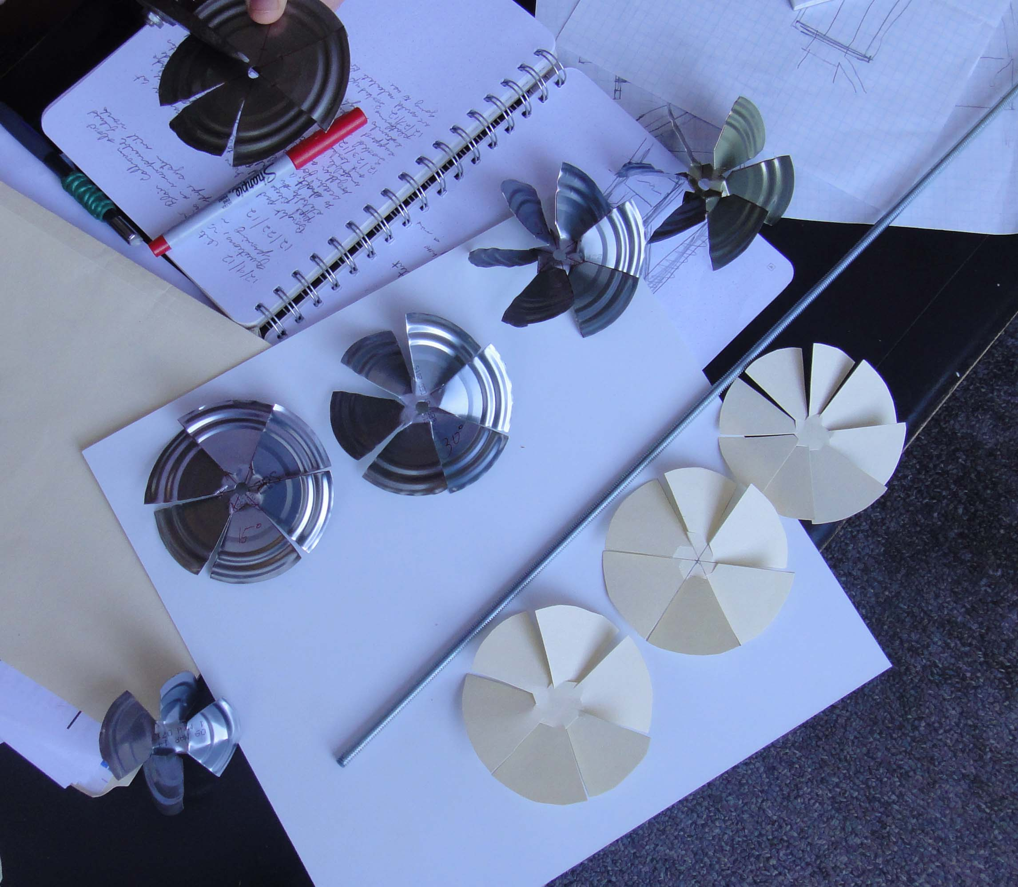

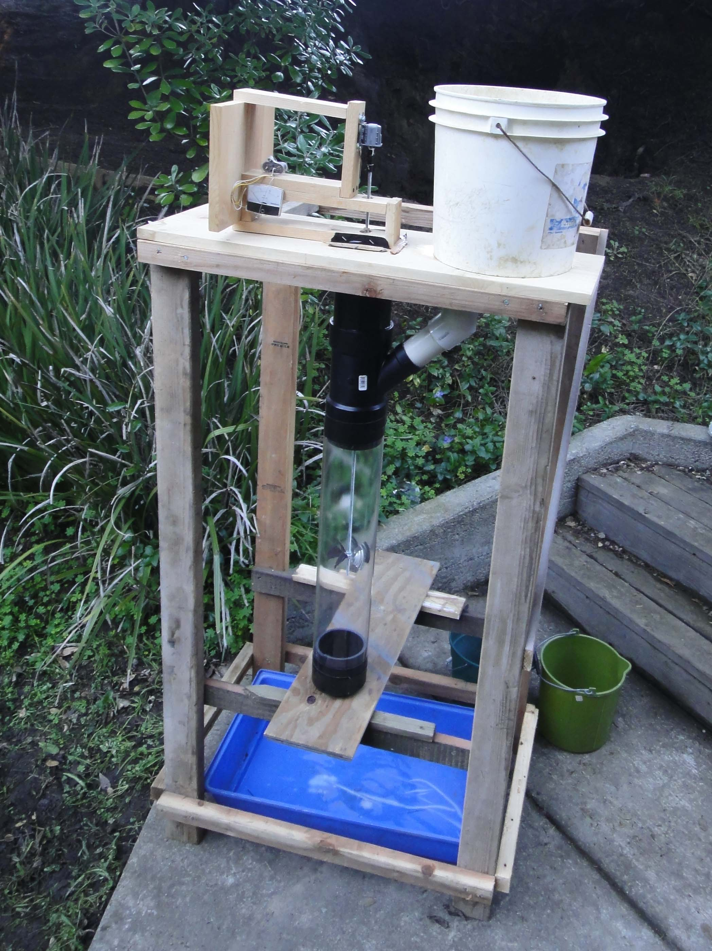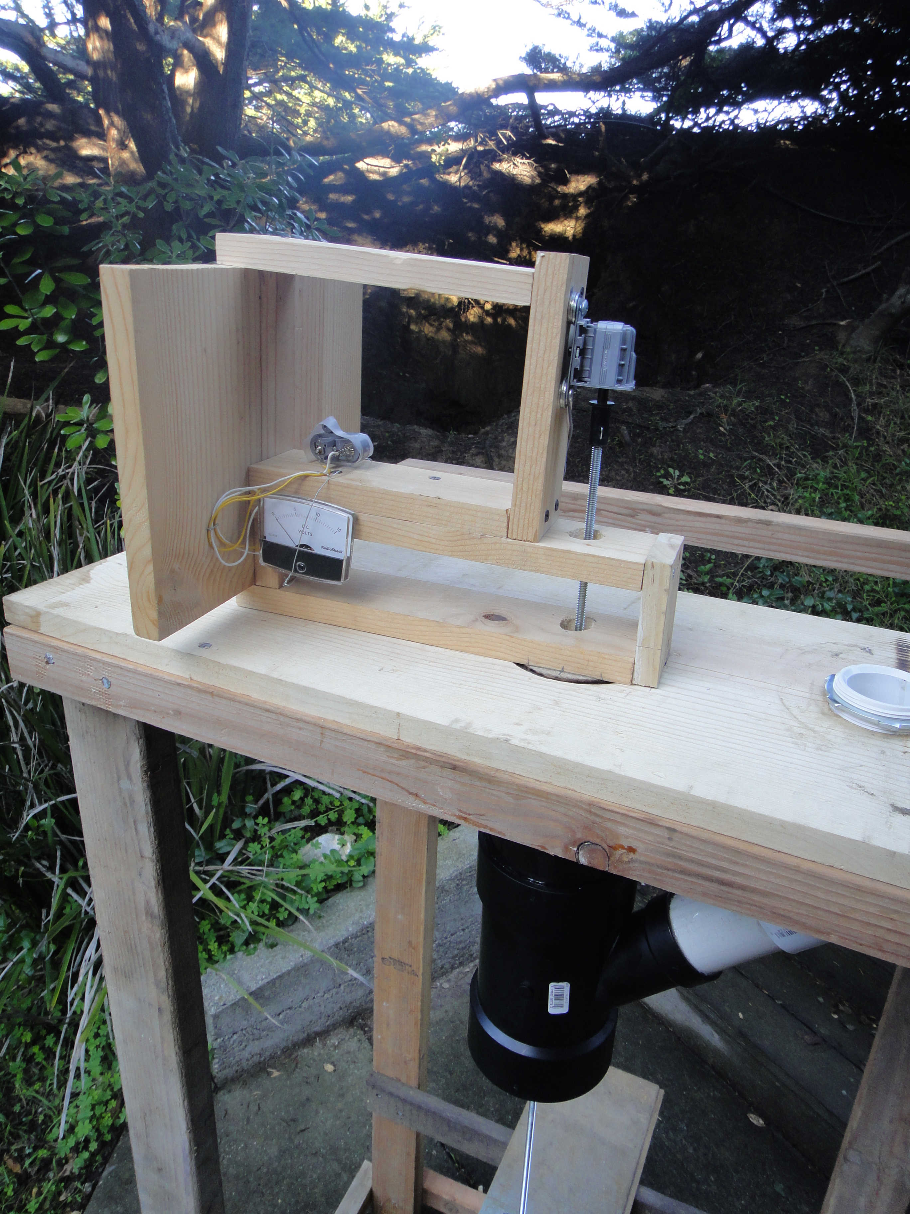

(Understanding of piping, flow rates, head height, electrical output., and some blade design (Kaplan).)

Understanding the difference between Kaplan, Francis, and Pelton turbines:

<https://www.youtube.com/watch?v=k0BLOKEZ3KU>

Kaplan: Impulse, low head (2-25m), high flow rate (70-800m3/s)

Francis: Reaction/impulse, medium head and medium flow

Animation: h<ttp://www.mekanizmalar.com/francis-turbine-top-v>iew.html

http://www.mekanizmalar.com/francis-turbine.html

Pelton: Reaction, high head (300-4000m), low flow rate

Animation: http://www.mekanizmalar.com/pelton-turbine.html

